**Amylase Concentration on Starch Breakdown**

**Introduction:**

Digestion of carbohydrate is initiated in the mouth by the action of hydrolytic enzyme in saliva call amylase. This enzyme is a major protein found in saliva. The optimal pH for this enzyme is about 7, so its action is inhibited by the acidic stomach juices when food enters the stomach. In the small intestine, polysaccharide digestion is reinitiated by pancreatic amylase, an enzyme that is similar but not identical to salivary amylase. Both enzymes cleave the bonds that link glucose molecules into starch and glycogen. The saliva amylase first hydrolyzes the polysaccharides to small chains of polysaccharides, call dextrins. The dextrins, in turn, are broken down into di and trisaccarides by the pancreatic amylase.

In this exercise, you will study the hydrolysis (breakdown) of starch by the enzyme, amylase. The enzyme reaction can be represented in a simplified form as follows:

**Amylase, Water**

**Starch (substrate) Simple Sugars**

The reaction can be detected by the following decrease in the amount of starch present in an enzyme reaction mixture with the use of iodine. Iodine staining is frequently used to follow the course of starch disappearance because starch turns blue-black when stained with iodine while simple sugars do not. If time is held constant, then the amount of starch breakdown should be related to the amylase concentration. With the help of your salivary glands, you will be setting up a series of dilutions to calculate what concentration of amylase is needed to break down starch.

**Materials:**

Agar-starch Plate

Wide Pipette

Pipette

10 ml graduated cylinder

Paper cup

100 ml beaker

5 test tubes/rack

Beaker

**Procedure:**

1. Obtain a pattern for arrangement of well in the petri dish. Place under petri dish. Using the cut pipette, make 9 wells as on pattern.
2. Label the wells 1-9 with marker on back of petri dish.
3. Here’s the fun part!! One person of your lab group needs to spit into the paper cup. You will need about 2 mLs of spit. (Chewing on a rubber band might be helpful. No throat clearing, we want saliva, not mucus).
4. Fill the water well before using your pipette on saliva.
5. Make a dilution series of your sample of spit with the help of your instructor. When you remove the 1mL from the previous test tube, fill your wells as you go. In-between test tubes/wells wash and rinse your pipette well by drawing up and expelling water three times. Fill in your concentrations of saliva in data table.

**(1 ml = 1000 µl or 0.1ml = 100 µl)**

C:\Documents and Settings\08hopkak\Local Settings\Temporary Internet Files\Content.IE5\CX2F8LA7\MCj02910390000[1].wmf C:\Documents and Settings\08hopkak\Local Settings\Temporary Internet Files\Content.IE5\CX2F8LA7\MCj02910390000[1].wmf etc……

2 ml of saliva 1 ml saliva + 9 ml water= 10 ml

Remove 1 ml

Remove 1 ml

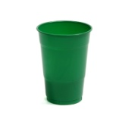

|  |  |  |  |
| --- | --- | --- | --- |
| Well Number | Sample  Concentration level | Hypothesis  (biggest to smallest) | Ring Diameter (mm) |
| 1 | Control (water) |  |  |
| 2 TT#1 | Saliva________ |  |  |
| 3 TT#2 | Saliva________ |  |  |
| 4 TT#3 | Saliva________ |  |  |
| 5 TT#4 | Saliva________ |  |  |
| 6 TT#5 | Saliva________ |  |  |
| 7 | Conc. Saliva |  |  |
| 8 | Amylase Extract |  |  |
| 9 | Pancreatic Extract |  |  |

1. After samples have been loaded into the wells, place lid on the dish. Be very careful to not tilt the dish. The dish should not be moved at this time.
2. The dish should remain at room temperature for 12 hours before iodine staining.
3. Dispose of paper cup and wash all equipment with soapy bleach water and rinse well.

**Next day: Detection of Amylase Activities**

1. Fill dish with just enough water to completely cover the wells. Place about 2-3 dropperfuls of diluted iodine solution onto the agar in the dish. and swirl to mix.
2. Let sit for about 5 minutes.
3. Discard the water, measure the diameter (in mm) of the clear rings around each well and record your results. The rings can be seen clearly by holding the dish over a white piece of paper.
4. Throw away the gel by wiping it our with paper towel, then the plates and lids should be washed with a mild detergent/bleach water and rinsed with water.

**Analysis:**

1. Using the chart below, make a line graph of your data. (Exclude wells 1,7,8,9). Plot the diameter of the rings as a function of the concentration of amylase.

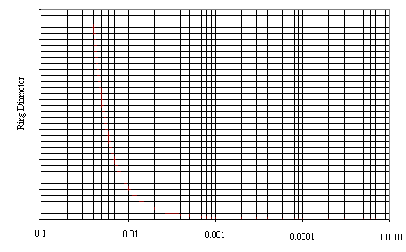

1. What conclusions can you make from your data (include all data not just what you have graphed)?
2. What was the need for water in one of the wells?
3. What are some other factors that we could have used to affect the rate of the enzymatic activity?
4. **Explain** why the rings formed in the agar-starch gels.